EDM Reporting User Manual

Overview

This document introduces EDM Reporting Utility. It’s aimed at programmers who will develop Output reports on Landmark’s EDM platform or people who need to be familiar with EDM Reports Development concepts.

Landmark Graphics Corp,
Calgary, Canada.

Revised: August 28, 2008
Released: September 2003

Revision History

Revision Date | Revision By | Comments | Project
2011-03-10 | Jawad Hashmi | Updated Debugging Crystal Reports section, the old report manager has been replaced with Report Service. With the current architecture the ReportServiceTester can be used to debug the reports. | OpenWells  Output Reports
2010-04-15 | Jawad Hashmi | Few more tags are introduced for schematics. | OpenWells  Output Reports
2009-04-17 | Jawad Hashmi | Included information about the display_filter tag in the report configuration file. | OpenWells  Output Reports
2008-12-02 | Jawad Hashmi | Updated information about the current date entered as value of filter_value=”{today}” in the filter_parameter. | OpenWells  Output Reports
2008-08-28 | Jawad Hashmi | Included information about <extension_jar> tag to mention the jar files containing custom java classes to over ride the whole standard xml data generation or for a single node. | OpenWells  Output Reports
2008-05-20 | Jawad Hashmi | Included information about the <SuppressinIWF> tag used by iWellFile in Report Configuration file’s application section. | OpenWells  Output Reports
2008-01-23 | Jawad Hashmi | Added two more tags <options> and <gen_key> in Report Configuration File section, | OpenWells Output Reports
2008-01-4 | Jawad Hashmi | Added Compass and Profile Plots integration. | OpenWells Output Reports
2007-08-28 | Irtaza Hassan | Added Usage Information for Custom Picklists for and Incorporating User Entered Parameters | OpenWells Output Reports
2007-06-14 | Irtaza Hassan | Added BHA and Wellbore Schematic related information | OpenWells Output Reports
2007-02-13 | Irtaza Hassan | Updated Information on Usage of Filters in Configuration Files | OpenWells Output Reports
2006-10-27 | Irtaza Hassan | Updated Information on Usage of Filters in Configuration Files | OpenWells Output Reports
2006-08-14 | Irtaza Hassan | Added Usage of Filters in Configuration Files | OpenWells Output Reports
2004-05-19 | Ali Rezazadeh | Updated Custom Reports section | OpenWells  EDM Output Reports
2003-09-23 | Asim Israr | Document Review and Formatting | OpenWells Output Reports
2003-09-15 | Shuja Nawaz | Document Review. | OpenWells Output Reports
2002-10-18 | Joel Romero | Document Creation. | OpenWells Output Reports

Contents

About EDM Reporting Utility 5
High Level Concepts of EDM Reporting 5
Report Builder 5
Report Builder 5
File Manager 5
Crystal Reports 5
XML 5
File Manager 7
XML Data Generator 7
Report Manager 7
Work Flow 10
Optimized data generation 11
Parent Relationships 12
Report Manager Data Filter 12
Report Manager Schema Filter 13
Components of a Report 14
Report Configuration Files 15
Generated Data 20
Resulting Output 21
Configuration Filters 23
Using the Tool Kit 33
General Notes 33
Adding a New Output Report 33
Creating a new Report Configuration file 35
Updating a Report file 35
Development Techniques for Crystal Reports 36
Debugging Crystal Reports 36
Developing Custom Reports 37
Generic XML Data Generation 37
Over-riding XML Generation of a Specified Business Object 37
Complete Over Riding of XML Generation 38
Developing Java classes for Custom Reports 39
Including BHA and Wellbore Schematics in Crystal Reports 48
BHA Schematics 48
Wellbore Schematics 51
Compass and Profile Plots integration. 54
Compass Plots 54
Profile Plots 59

About EDM Reporting Utility

The purpose of this document is to provide the necessary information that enables users to add new output reports, modify existing output reports or developing custom reports for EDM applications using the EDM Reporting Tool Kit. The Tool Kit consists of the EDM Admin Utility, EDM Report Builder, and EDM Report Manager utilities that are all installed as shared components of EDM Data Services. Output reports replace the term ‘printed reports’ from previous documentation.

An output report is a predefined report generated from a data set. It displays information in a preformatted file that can then be saved or printed. A typical output report consists of a pair of files: a Report Configuration (.XML) file and a Crystal Reports (.RPT) file. The report configuration file is an XML file that defines report-specific settings such as the report title, menu display, and custom labels. It also defines the EDM data objects that need to be generated for this particular report. The crystal report file is the report layout generated using Crystal Reports 9 or higher. All output report files can be added, deleted, and updated in the EDM database using the EDM Administration Utility.

High Level Concepts of EDM Reporting

Report Builder

EDM Report Builder is the underlying reporting engine. It is installed as a shared component of EDM . Its design is based on the following principles:

- Build an extendable and common reporting system for EDM applications
- Allow clients and support to build Custom reports with minimal effort
- Client’s custom reports are separate from Landmark provided reports.

Report Builder’s top-level design is demonstrated in the following diagram:

Report Builder
File Manager
XML Data Generator
Report Manager
Crystal Reports
XML
MD_SYS_REPORT_TABLEsee the metadata information r the report. ot be hard coded. s in the rep one report.port.

Figure 1.1

The process of viewing a report through Report Manager has five general steps:

- Loading the Report Manager
- Loading RPT file and return tables and fields used
- Creating XML report data
- Loading XML report data and filter schema
- Preview report in Report Manager

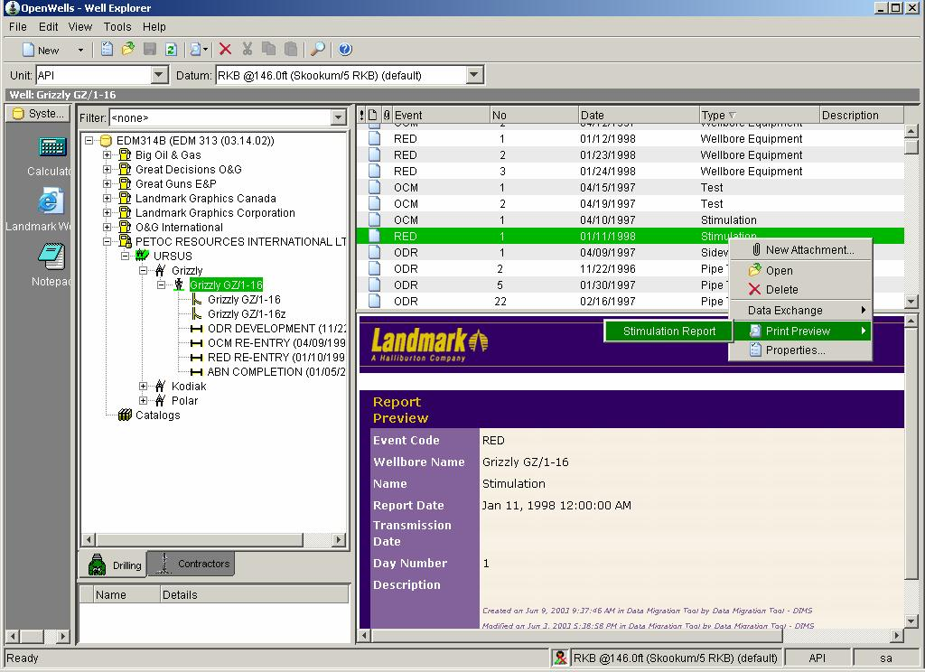

Figure 1.2

File Manager
The file manager provides access to the database in order to download files when OpenWells starts. All reporting files have been stored in the database in BLOB or a similar format (depending on the database vendor). Upon each request to access a file, the file would be searched for on the local drive, if the file was found, its time-stamp would be compared with the time-stamp of the file in the database. If the time stamp of data base file is more recent, the local drive file would be refreshed from database. If the file is not found on the local drive, it will be downloaded from the database. All proper directories will be created accordingly, in order for a file path on local drive to be similar to the database path.
Please see Figure 13 for a visual look of functionality of File Manger.

Note: You should restart OpenWells after adding files through EDM Admin Utility to enable the file manager to refresh the files in your directory structure.

XML Data Generator
The XML generation uses the data source section of the configuration file to produce the XML data needed in the report. The data generation is based on a description of the data in the EDM data model. The input to this section is a set of XML tags that define the EDM tables. The related records from the EDM tables will be converted to XML data. More detail on this Data Generation is presented in the Configuration file section of this document.

Report Manager
The EDM Report Manager displays a preview of the output report and allows the user to perform several operations including Print, Export to file (.PDF, .XLS, .DOC, .RTF), Zoom, and Multi-report preview

Diagram showing the functionality of File Manager:

Start
Check for file on local file system
Is File Found?
Yes
No
Compare time stamp with EDM file
EDM
Is Latest File?
Yes
Load file from local file system into report manager
End
No
Load file from EDM DB and save to local file system.
EDM

Figure 1.3
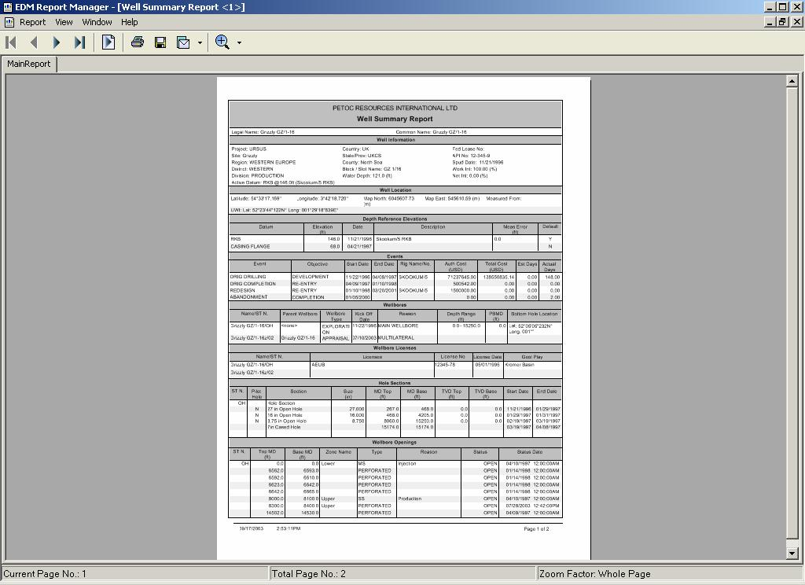

Figure 1.4

Work Flow

The XML files in the database are primarily configuration files that define specific settings for a report. The Crystal Report files contain the report layout to be produced.

Input data for a report is defined in the configuration file, raw data would be generated using the relationships defined in the <data_generation> section of the configuration file.

The EDM Report Manager is an application that takes as inputs the root folder for the output report files from which it will derive the location of the schema file for the EDM database (EDM.XSD) and the developed Crystal Report (.RPT) file. In addition, it also takes as inputs the Report Configuration file, and the XML data produced, and from these inputs, displays a preview of the output report.

XML Data Generator
(uses Data_generation section from configuration file)
Crystal Reports
EDM.xsd
XML Configuration
File
XML
Data
EDM Report Manager
Output reports in different formats (PDF, Excel, Word …)

Figure 2.1

Optimized data generation
OpenWells relies on Report Builder to generate the raw XML data for a Report. Each report has a configuration XML file that defines the data DS is to create. This looks like,
..
<data_source>
<data_generation>
<DM_REPORT_JOURNAL>
<DM_AFE rel="parent">
<DM_AFE_COST/>
<DM_AFE_EVENT_LINK/>
<DM_AFE_SUPP/>
</DM_AFE>
<CD_WELL rel="parent">
<CD_SITE rel="parent">
<CD_PROJECT rel="parent">
<CD_POLICY rel="parent"/>
</CD_PROJECT>
</CD_SITE>
</CD_WELL>
<DM_EVENT rel="parent"/>
<CD_RIG rel="parent"/>
</DM_REPORT_JOURNAL>
</data_generation>
</data_source>

This excerpt comes from a Cost Estimate Report. The following observations could be made about above data generation XML:
- The starting point for XML data generation is a DM_REPORT_JOURNAL. It means most likely it is a Standard Report.
- DM_AFE if defined as a parent of DM_REPORT_JOURNAL. Only the pre-existing set of parent relationships are allowed to be used in the configuration file. The complete list of the defined relationships can be found at Parent Relationships section.
- DM_AFE has a one to many relationship to DM_AFE_COST, DM_AFE_EVENT_LINK and DM_AFE_SUPP.

Parent Relationships
The following table defines the implemented parent relationships. All parent relationships have been defined and hard coded in Data Services layer. Adding a new parent relationship is relatively a straight forward process. These links may be increased if required by reports.

Table Name | Parents Defined
DM_EVENT | CD_WELL
CD_POLICY | Null – Top level
CD_PROJECT | CD_POLICY
DM_REPORT_JOURNAL | DM_EVENT, CD_WELL, CD_WELLBORE, DM_AFE, CD_RIG
CD_RIG | CD_CONTRCTOR
DM_RIG_OPERATION | CD_RIG
DM_RIG_OPERATION_EVENT_LINK | DM_EVENT, DM_RIG_OPERATION
CD_SITE | CD_PROJECT
CD_WELL | CD_SITE
CD_WELLBORE | CD_WELL, CD_DATUM
CD_WELLBORE_UWI | CD_LOCATION, CD_WELLBORE
CD_WELL_UWI | CD_LOCATION, CD_WELL
DM_CASING | CD_ASSEMBLY
CD_ASSEMBLY | DM_REPORT_JOURNAL
DM_BIT_OP | CD_ASSEMBLY, CD_WELL, DM_EVENT, DM_DAILY, CD_WELLBORE, CD_WELLBORE_FORMATION, CD_ASSEMBLY_COMP, DM_BHA_RUN
DM_BHA_OP | DM_DAILY, DM_BHA_RUN
DM_BHA_RUN | CD_ASSEMBLY
CD_SURVERY_HEADER | CD_SURVERY_TOOL
DM_SUPPORT_VESSEL_DAILY | DM_SUPPORT_VESSEL
DM_PERSONNEL_DAILY | DM_PERSONNEL
DM_BULK_TRAN | DM_BULK
DM_MUD_PRODUCT_TRAN | DM_MUD_PRODUCT
DM_DAILY | DM_EVENT, CD_WELLBORE
CD_WEQP_GAS_LIFT_MANDREL | CD_ASSEMBLY_COMP
CD_WELLBORE_FORMATION | CD_WELLBORE, CD_WELL
DM_DST | CD_ASSEMBLY

Report Manager Data Filter
For speed purposes the reporting system scans the rpt file and creates an XML file listing the tables and fields used in the report. The following is an example showing table CD_PROJECT and CD_POLICY and some of the fields used,

<database>
<table name=”CD_PROJECT”>
<column name=”project_id” />
<column name=”policy_id” />
<column name=”project_name />
…
</table>
<table name=”CD_POLICY”>
<column name=”policy_id” />
<column name=”custerm_name” />
…
</table>
…
</database>

Only tables with its field names that are in the report are listed in this XML structure. The applications can then optimize or slim down the data to what is used in the report.

Report Manager Schema Filter
To load an XML file into ADO.net, a schema is used. The entire schema file is generated in the Administration Tool. Generating of schema fine is based on the metadata tables defined in the data base.

This schema file is itself an XML file that describes the tables and fields used in the XML being loaded. Example schema file,

<?xml version="1.0" encoding="UTF-8"?>
<xs:schema xmlns:xs="http://www.w3.org/2001/XMLSchema" version="EDM 313 (03.13.01)(03.13.01)">
<xs:element name="report">
<xs:complexType>
<xs:sequence>
...
<xs:element name="CD_PROJECT">
<xs:complexType>
<xs:attribute name="project_id" type="xs:string" use="optional"/>
<xs:attribute name="project_name" type="xs:string" use="optional"/>
...
<xs:element name="CD_WELL">
<xs:complexType>
<xs:attribute name="active_datum_desc" type="xs:string" use="optional"/>
<xs:attribute name="active_datum_id" type="xs:string" use="optional"/>
<xs:attribute name="active_ui_unitsys_id" type="xs:long" use="optional"/>
…

As of this writing the schema file is 6.0 MB formatted and 5.8 MB unformatted (formatted means having tabs and line breaks). This is a large file to load and contains a huge number of tables and fields. To solve this load problem Report Manager filters the schema down to what is in the report file, much as what is described in the “Report Manager Data Filter” section. Typically a filtered schema file is less than 200 KB for a report.

Besides being faster, a filtered schema file does have one unavoidable problem. The report XML must also be filtered down to match the schema file. All tables and fields are optional but adding more tables or fields will cause Report Manager to throw an exception “Table could not be found”. It means if there is some data in the XML file which does not correspond to schema the “Table “Table could not be found” will arise. The only solution to this problem is to ensure XML data conforms to the schema.

With this is mind we will go back to OpenWells report data optimization. Report Builder received a list of used tables and their fields from the Report Manager. This list is in XML format which includes all of the tables used in the report and specific fields in each table. The XML data produced by Report Builder is hence optimized according the list of tables and fields used in the report.

The following figure illustrated the high level design of the Report Builder architecture.

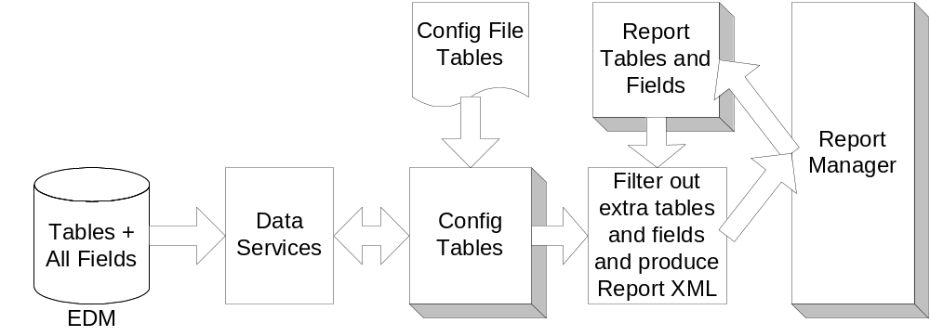

Figure 2.2

Components of a Report

Definition of a report begins with the configuration file that describes the construction of the report.

Report Configuration Files
A configuration file contains the necessary detail for producing a report. There is a one to one relationship between reports and configuration files. For each report there must be one configuration file existent and for each report and each configuration file can only correspond to one report.

The following table defines the outline of a configuration file:

Sections | Parameters | Description
<applications> |  | Defines the applications that are allowed to use the report. EDM is a multi-application database. More than one application may be allowed to use a given report (e.g., OpenWells and Compass could both use the same report.)
 | <app> | Defines the application name which will use the report. <app>OpenWells</app>. E.g OpenWells, Compass, WellPlan and Wellcost.
 | <SuppressinIWF> | This tag is used by iWellFile to show or hide this report to the iWellFile users.  <SuppressinIWF>NO</SuppressinIWF>. This will show the report to the iWellFile user as well changing to YES will hide the report to the iWellFile users.
<settings> |  | Defines a set of XML data that is copied directly to the XML data generated by Report Builder. Report Builder produces the necessary XML data for the report. The <settings> section of configuration file is directly copied into the XML data without any alternation. Some of the XML tags are also used as directives to load the report files.
 | <schema_file> | Defines the schema file name. The schema file should be located in the “OutputReports/common” directory.
 | <report_file> | The report file XML tag defines the secondary files that are needed in producing this report. The directory location is the same directory as configuration file. For instance some image files might be needed for the report.
 | <common_file> | The common file XML tag defines the secondary files that are needed to define this report. However their directory path is in the common directory (“OutputReports/common”).
 | <main_report> | Defines the main report file name. Main report refers to the main Crystal Report file. The main report should be located in the same directory that configuration file was discovered.
 | <report_label> | The report label XML tag is used to define the labels and constant text that are used in the report. The main reason to use <report_label> is to avoid hard coding any text that might be changed to support a different language. For instance:  <report_labels section="report name" section_label="Daily Cost Report" />
 | <options> | The option tag can be used to get user feed to show or hide section on that feed back in the report. User’s last selected options are saved in the registry for each report and each particular user, and will be shown next time the same report is run.  User can check or uncheck the box to show/hide each section.  Text box can be shown to get the user feed back. box.  Combo box can also be shown to get the specific options from the user.  Options can be shown to the user on the basis of security level if used in the configuration file.  The sample tag can be as under,  <options>  <option type="edit" id="WaterMark" prompt="Water mark:" tooltip="Enter the water mark text. Leave blank for no water mark."/>  <option type="combobox" id="WaterMarkOrientation" prompt="Water mark text orientation:" default_value="Horizontal" tooltip="Water mark text angle.">  <value>Horizontal</value>  <value>Vertical</value>  </option>  <option type="edit" id="WaterMarkSize" prompt="Water Mark Text Size:" default_value="44" tooltip="Enter the watermark text size in points."/>  <option type="checkbox" id="PageHeader" prompt="Include Page Header" default_value="1"/>  <option type="checkbox" id="WellInfo" prompt="Include Well Information" default_value="1"/>  <option type="checkbox" id="OperationSummary" prompt="Include Operation Summary" default_value="1"/>  <option type="checkbox" id="HoleSections" prompt="Include Hole Sections" default_value="1" security_level=”5”/>  </options>  The following dialog will be shown to the user.  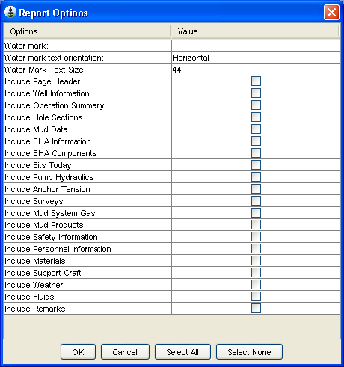  security_level is optional if present then application will show the option to the user (in the Dialog) whose security level is equal or greater then mentioned in tag. Other wise all options will be shown.
 | <gen_key> | A table with the variable number of records will be generated by this tag. i.g <gen_key>100</gen_key>  The application will generate a table DT_STATIC_KEY in the generated xml with 100 records in it. As the arrays in Crystal Reports can not contain more then 1000 records so user may set less then 1000.  The generated data will look like  <DT_STATIC_KEY static_key_id="1" new_key="1" report_id="" />  <DT_STATIC_KEY static_key_id="2" new_key="2" report_id="" />  <DT_STATIC_KEY static_key_id="3" new_key="3" report_id="" />  <DT_STATIC_KEY static_key_id="4" new_key="4" report_id="" />  <DT_STATIC_KEY static_key_id="100" new_key="100" report_id=""/>
 | <extension_jar> | This tag is used to mention the jar files containing the custom java classes to over ride the whole xml data generation or for a single node.  <extension_jar>MyCustomClass.jar</extension_jar>
 | <display_filter | This tag is used to show report in the Print Preview menu if it fulfills the mentioned condition. E.g if we want the report to be only visible for DRL event code then we code it as  <display_filter condition_1="event_code=DRL” />  We can include more then one conditions in the same <display_filter e.g we want to see the report event_code DRL and COM.  <display_filter condition_1="event_code=DRL" condition_2="event_code=COM” />  The report will be visible if any one of the conditions is true. More conditions can be included as condition_3 condition_4 ……  We can also include two conditions with the AND relation if both the conditions are true then show the report like  <display_filter condition_1="event_code=ABN AND CD_WELL.tight_group_id=uf9Qr" condition_2="event_code=COM AND CD_WELL.tight_group_id=uf9Qr" />  The report will only be visible if the event_code is ABN or COM and the CD_WELL.tight_group_id=uf9Qr.  We can include the check for the field with the table name which can be accessed as the parent of the business object for which the report is being run. E.g the above condition can be included in the ReportJournal or Daily level reports since CD_WELL serves as the parent of DM_REPORT_JOURNAL.
<menus> |  | This tag defines the menu behaviour for the report. The <menu> section contains the following parameters:
 | <report_name> | The name of the report.
 | <class> | The name of the Java class that will produce the report.  Considering the existing implementation, this class name is always set to “com.lgc.dws.EDM.reportbuilder.ReportBuilder”. This class name could be changed to any other properly designed code that is can produce the XML data. The logic behind this parameter is to provide flexibility to define other code for specialty reports.
 | <display_text> | Defines the text displayed in the output reports menu of your EDM application (i.e. OpenWells). This parameter provides the flexibility for internationalization or providing customized naming for the reports.
 | <mnemonic> | A short cut to activate the report from your EDM application (i.e. OpenWells).
 | <visible> | When set to TRUE, the report is displayed in the application even if it cannot be used in the application.  When set to FALSE, the report is not visible in the application.  Note: This would hold true even if the <enabled> parameter were set to TRUE.
A sample of a <menu> section could be shown as the following:
<menu>
<report_name>DailyCost</report_name>
<class>com.lgc.dws.EDM.reportbuilder.ReportBuilder</class>
<display_text>Daily Cost Report</display_text>
<mnemonic>C</mnemonic>
<enabled>TRUE</enabled>
<visible>TRUE</visible>
</menu>
<data_source> |  | This section defines the source of XML data for this report.  Note: Only one of the following XML tags can be present in this section.
 | <data_generation> | This parameter allows Report Builder to generate the necessary XML data for producing this report. For instance a data generation code may look like the following:  <data_source>  <data_generation>  <DM_REPORT_JOURNAL>  <DM_AFE rel="parent">  <DM_AFE_COST/>  </DM_AFE>  <CD_WELL rel="parent">  <CD_SITE rel="parent">  <CD_PROJECT rel="parent">  <CD_POLICY rel="parent"/>  </CD_PROJECT>  </CD_SITE>  </CD_WELL>  </DM_REPORT_JOURNAL>  </data_generation>  <picklists>  <DM_PK_COST_LIST/>  </picklists>  </data_source>  In this example code the host is DM_REPORT_JOURNAL, therefore the data generation begins from a DM_REPORT_JOURNAL.  <DM_AFE rel="parent"> defines DM_AFE as a parent of DM_REPORT_JOURNAL.  Next line (<DM_AFE_COST/>) means from DM_AFE find all DM_AFE_COST that are children of DM_AFE. The attribute of rel=”parent” means relationship is parent. Default for relationship is children.  The configuration files also supports a ‘filtering’ capability, somewhat similar to the ‘WHERE’ clause used in an SQL ‘Select’ statement. A detailed description of the filters is given at the end of this section (Configuration Filters)
 | <input_file> | This parameter means the data is already produced in a file. The file name has to pass as an argument to the Report Builder. This argument is a part of API and its definition is out of the scope of this document.  <data_source>  <input_file/>  </data_source>  The file name that contains the XML data is not static and therefore cannot be included in the configuration file. The file name is instead passed as an argument to Report Builder at run time.
 | <input_string> | This parameter defines the data present as a string in the argument passed to the Report Builder. This argument is a part of API and its definition is out of the scope of this document.  <data_source>  <input_string/>  </data_source>

Generated Data
The generated data contains four sections.
- <data> Section: The XML data that is produced by Report Builder. The data that is produced closely follows the format that is defined in the <data_generation> section of the configuration file. For example, the following XML and resulting output are displayed. Note: Due to large size of produced data, only a portion of the data file has been shown.

XML Data Source section

<data_source>
<data_generation>
<DM_REPORT_JOURNAL>
<DM_AFE rel="parent">
<DM_AFE_COST/>
<DM_AFE_EVENT_LINK/>
<DM_AFE_SUPP/>
</DM_AFE>
<CD_WELL rel="parent">
<CD_SITE rel="parent">
<CD_PROJECT rel="parent">
<CD_POLICY rel="parent"/>
</CD_PROJECT>
</CD_SITE>
</CD_WELL>
<DM_EVENT rel="parent"/>
<CD_RIG rel="parent"/>
</DM_REPORT_JOURNAL>
</data_generation>
</data_source>

Resulting Output
<?xml version="1.0" encoding="UTF-8"?>
<report>
…
<from_app>
<left_logo>C:\Documents and Settings\ARezazadeh\My Documents\My Pictures\HalliburtonLogo.jpg</left_logo>
<right_logo>C:\Documents and Settings\ARezazadeh\My Documents\My Pictures\HalliburtonLogo.jpg</right_logo>
<report_shading>true</report_shading>
</from_app>
<metadata>
<md_CD_PROJECT project_name_L="Project"/>
<md_CD_RIG rig_name_L="Rig Name"/>
<md_CD_SITE site_name_L="Site"/>
<md_CD_WELL active_datum_desc_L="Active Datum" spud_date_L="Spud Date" well_common_name_L="Common Well Name" well_uwi_L="UWI"/>
<md_DM_AFE afe_desc_L="Description" afe_no_L="AFE No" currency_code_L="Currency" currency_exch_rate_DP="3" currency_exch_rate_L="Exchange Rate" currency_exch_rate_MID="153" currency_exch_rate_PRC="0.0010" department_L="Department Name" estimated_days_DP="2" estimated_days_L="Est Days" estimated_days_MID="218" estimated_days_PRC="0.01" estimator_L="Estimator" project_name_L="Project Desc" remarks_L="Comments"/>
<md_DM_AFE_COST afe_amount_DP="2" afe_amount_L="Cost Est Base Curr" afe_amount_MID="48" afe_amount_PRC="0.01" cost_class_L="Class" cost_code_L="Code" cost_description_L="Description" cost_subcode_L="Subcode" cost_supp_DP="2" cost_supp_L="Other Cost" cost_supp_MID="48" cost_supp_PRC="0.01"/>
<md_DM_AFE_SUPP afe_supp_no_L="Supplemental AFE No" approved_by_L="Approved By" cum_supp_cost_DP="2" cum_supp_cost_L="Supplemental AFE Total" cum_supp_cost_MID="48" cum_supp_cost_PRC="0.01" date_approved_L="Date Approved" date_supplement_L="Supplement Date" pool_L="Pool" remarks_L="Comments"/>
<md_DM_EVENT date_ops_end_L="End Date" date_ops_start_L="Start Date" event_type_L="Event"/>
<md_DM_REPORT_JOURNAL date_report_L="Report Date" report_no_L="Report No"/>
</metadata>
<data>
<DM_REPORT_JOURNAL date_report="1998-09-17T00:00:00" report_no=" 1"/>
<DM_AFE afe_id="OdmSIYO0fs" afe_desc="NEW EXPLORATORY WELL" afe_no="Z7083677" currency_code="US" currency_exch_rate="0" estimated_days="12" estimator="Duplantis, John"/>
<DM_AFE_COST afe_id="OdmSIYO0fs" afe_amount="160860" cost_class="TANC" cost_code="491" cost_description="Tubing 1" cost_subcode="0010"/>
<DM_AFE_COST afe_id="OdmSIYO0fs" afe_amount="8620" cost_class="TANC" cost_code="491" cost_description="Tubing 2" cost_subcode="0020"/>
<DM_AFE_COST afe_id="OdmSIYO0fs" afe_amount="132000" cost_class="TANC" cost_code="495" cost_description="XMAS Tree" cost_subcode="0010"/>
<DM_AFE_COST afe_id="OdmSIYO0fs" afe_amount="15000" cost_class="TANC" cost_code="495" cost_description="Miscellaneous" cost_subcode="0020"/>
<DM_AFE_COST afe_id="OdmSIYO0fs" afe_amount="68020" cost_class="TANC" cost_code="497" cost_description="Packers, seals" cost_subcode="0010"/>
<DM_AFE_COST afe_id="OdmSIYO0fs" afe_amount="11820" cost_class="TANC" cost_code="497" cost_description="Nipples" cost_subcode="0030"/>
<DM_AFE_COST afe_id="OdmSIYO0fs" afe_amount="2400" cost_class="TANC" cost_code="497" cost_description="Pup Joints" cost_subcode="0060"/>
<DM_AFE_EVENT_LINK afe_no="Z7083677"/>
<CD_WELL active_datum_desc="Rotary Table @2.0ft (H&amp;P 79)" spud_date="1998-10-03T05:00:00" well_common_name="Landmark #2" well_uwi="N61.7066W 8753.18' FROM USC&amp;GS MONUMENT 'TECHE' SEC45 T15S"/>
<CD_SITE site_name="Landmark #2"/>
<CD_PROJECT project_name="PATTERSON"/>
<CD_POLICY customer_name="Landmark Graphics Corporation"/>
<DM_EVENT event_type="ORIG COMPLETION"/>
<report_labels section="report_name" section_label="Cost Estimate Report"/>
<report_labels section="rig_name_label" section_label="Rig Name/No."/>
<report_labels section="site_name_label" section_label="Site"/>
<report_labels section="project_name_label" section_label="Project"/>
<report_labels section="well_name_label" section_label="Well"/>
<report_labels section="code_total_label" section_label="Total for Code"/>
<report_labels section="class_total_label" section_label="Total for Class"/>
<report_labels section="estimate_total_label" section_label="Total Estimate"/>
</data>
</report>

- <report_labels> XML tags contain the labels needed in the report. One of the requirements for most of the reports is internationalization. In order to change the language of the report, there should not be any hard coded labels in the report. However there is a need to display a text in the report, which can not be hard coded. <report_labels> XML tag is used to define the labels for the report.

- <metadata> Section: The <metadata> section contains metadata from EDM tables that are used in the XML data section. The metadata section provides information on units and labels to be used in the report. The metadata section includes all of the EDM tables that are used in the report.

The following XML line presents a sample metadata information for DM_PUMP_OP.

<md_DM_PUMP_OP efficiency_DP="2" efficiency_L="Efficiency" efficiency_MID="154"
efficiency_PRC="0.01" flowrate_DP="1" flowrate_L="Output" flowrate_MID="75"
flowrate_PRC="0.1" flowrate_UL="gpm" liner_id_DP="3" liner_id_L="Liner Size"
liner_id_MID="124" liner_id_PRC="0.0010" liner_id_UL="in" md_op_DP="1" md_op_MID="122"
md_op_PRC="0.1" md_op_UL="ft" press_DP="1" press_L="Pressure" press_MID="185"
press_PRC="0.1" press_UL="psi" spm_DP="2" spm_L="SPM" spm_MID="114" spm_PRC="0.01" spm_UL="spm"/>

The following attributes can be found in the example:
_DP: Decimal Precision
_L: Label
_MID:
_PRC: Precision
_UL: Unit Label

- <from_app> Section: The <from_app> section contains a series of XML tags that is produced by the application. For example, image file paths for icons that are defined in the application are defined in this section.

Configuration Filters

A report developer can add filters in the configuration file to limit the amount of XML data produced. This helps in limiting the amount of filtering required to be done in Crystal Reports, thus making the report generation quicker.

Currently three types of filters are supported:

- filter
- filter_2
- filter_range
- filter_parameter

1. Using the “filter” clause in the configuration file:

Syntax:
<Host_Table filter="Reference_Table.Reference_Field=Host_Field"/>

Supported Operators:
=, <, >, <=, >=, !=, %=, >=+, <=+, >=-, <=-

Supported Data Types:
Date, Numeric and Text fields

Version History:
  - 2003.11 and later versions
  - 2003.16.1 and later versions for %=, >=+, <=+, >=-, <=- operators

If for example in a Daily Operations report we need to generate data for only the surveys that were entered on the current daily, the following lines will be added in the configuration file:

<DM_DAILY>
<CD_WELLBORE rel="parent">
<CD_SURVEY_STATION filter="DM_DAILY.date_report=survey_date"/>
</CD_WELLBORE>
</DM_DAILY>

Here CD_SURVEY_STATION = Host table name
DM_DAILY = Reference table name
date_report =Reference field name
survey_date= Host field name

The above configuration will generate only those records of CD_SURVEY_STATION where its survey_date is equal to the date_report field of DM_DAILY table.

The filter clause can be used with date, numeric or string fields; and it also supports <, <=, >, >=, >=+, >=-, <=+, <=- and!= to operators with date fields.

The >=+, >=-, <=+, <=- operators are new addition available in 2003.16.1.x and subsequent versions. These operators can be used to add/subtract number of days from dates. Continuing with the CD_SURVEY_STATION example, if in a Daily Operations report we need to generate data for all the surveys that were entered before or on the current daily, the following lines will be added in the configuration file:

<DM_DAILY>
<CD_WELLBORE rel="parent">
<CD_SURVEY_STATION filter="DM_DAILY.date_report>=survey_date"/>
</CD_WELLBORE>
</DM_DAILY>

The above configuration will generate only those records of CD_SURVEY_STATION where its survey_date is less than or equal to the date_report field of DM_DAILY table.

Now this poses a new problem if a company is using 06:00 am to 06:00 am reporting time and is using the reporting standard: Day 1, hh:mm - Day 2, hh:mm, Using Report Date of Day 2. Data for CD_SURVEY_STATION entered on Day 2 will not be added in the report since data for that date will be filtered out by our filter clause in the configuration file.

Now we can use the >=+ operator to generate CD_SURVEY_STATION data entered on Day 2 as well. This can be achieved by making the following changes in the filter clause:

<DM_DAILY>
<CD_WELLBORE rel="parent">
<CD_SURVEY_STATION filter="DM_DAILY.date_report>=+1survey_date"/>
</CD_WELLBORE>
</DM_DAILY>

The above configuration will generate only those records of CD_SURVEY_STATION where its survey_date is less than or equal to the date_report + 1 of DM_DAILY table. e.g.:

If we generate Daily Ops report for 02/22/2006, all CD_SURVEY_STATION records for the current wellbore will be generated where the survey_date <= 02/23/2006. If we had used >=+2 instead of >=+1 then all CD_SURVEY_STATION records for the current wellbore would have been generated where the survey_date <= 02/24/2006.
2. Using the “filter_2” clause in the configuration file:

Syntax:
<Host_Table filter_2="Reference_Table.Reference_Field=Host_Field"/>

Supported Operators:
=, <, >, <=, >=, !=, %=, >=+, <=+, >=-, <=-

Supported Data Types:
Date, Numeric and Text fields
Version History:
  - 2003.16 and later versions
  - 2003.16.1 and later versions for %=, >=+, <=+, >=-, <=- operators

This filter operates exactly like the filter clause explained in the previous section. Using the filter_2 clause with filter will be equivalent to an “AND” operator in used in SQL statements.

If for example in a Daily Operations report we need to generate data for all the surveys that were entered before or on the current daily, the following lines will be added in the configuration file:

<DM_DAILY>
<CD_WELLBORE rel="parent">
<CD_SURVEY_STATION filter="DM_DAILY.date_report>=survey_date"/>
</CD_WELLBORE>
</DM_DAILY>

Here CD_SURVEY_STATION = Host table name
DM_DAILY = Reference table name
date_report =Reference field name
survey_date= Host field name

Now if we want to add another condition that only survey’s for current event are produced instead of all events of a wellbore, we can use the filter_2 clause

<DM_DAILY>
<CD_WELLBORE rel="parent">
<CD_SURVEY_STATION filter="DM_DAILY.date_report>=survey_date" filter_2="DM_EVENT.date_ops_start<=survey_date"/>
</CD_WELLBORE>
</DM_DAILY>

The above configuration will generate only those records of CD_SURVEY_STATION where its survey_date is less than or equal to the date_report field of DM_DAILY table and survey_date is greater than current event’s starting date i.e. DM_EVENT.date_ops_start.

3. Using the “filter_range” clause in the configuration file:

Syntax:
<Host_Table filter_range="date_field=Host_Field"/>
Supported Operators:
=
Supported Data Types:
Date

Version History:
  - 2003.16.0 and later versions
  - 2003.16.1 and later versions for parameter_item table to use parameter values in output reports

If the objective of the report is to take a date range from the user then the filter_range can be used. An example of its usage can be seen in the Multiwell Management Summary report. Here the objective is to generate DM_REPORT_JOURNAL data for a date range specified by the user.

<DM_EVENT>
<DM_REPORT_JOURNAL filter_range="date_field=date_report"/>
</DM_EVENT>

Here
DM_REPORT_JOURNAL = Host table name
date_report= Host field name for which the range is taken from the user

The above configuration will cause OpenWells to pop-up a dialog box when this report is selected for generation. The dialog box takes two dates (Start and End dates) from the user and then OpenWells generates XML data for only those records of DM_REPORT_JOURNAL where its date_report falls within the date range given by the user.

The user can also append filter_caption and filter_label at the end of this clause to change the default Caption and Label on the date range dialog box, e.g.:

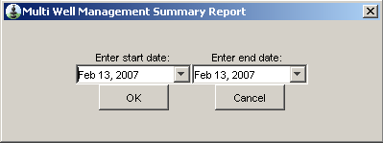
<DM_REPORT_JOURNAL filter_range="date_field=date_report"
filter_caption ="Multi Well Management Summary Report"/>

Using Parameter Value in OutputReports:

The selected date range is used to filter the records returned by OpenWells for an output report. The selected date range is also written in the xml data generated for the report under a custom table named parameter_item. This allows the report developer to use the parameter values in the report. The report developer only has to add the parameter_item table in the report. An example of what the generated xml will include for a parameter:

<parameter_item table="DM_REPORT_JOURNAL" column="date_report" start_param_value="2006-08-28T00:00:00" end_param_value="2007-08-28T23:59:59" />

- Using the “filter_parameter” clause in the configuration file:

Syntax:
<Host_Table filter_parameter="text_field=Host_Field"/>
or
<Host_Table filter_parameter="numeric_field=Host_Field"/>
or
<Host_Table filter_parameter="date_field=Host_Field" filter_value=”{today}”/>

Supported Operators:
=, <, >, <=, >=, !=, %=

Supported Data Types:
Numeric and Text fields, Picklists

Version History:
  - 2003.16.0 and later versions
  - 2003.16.1 and later versions for Multiple Values, Pre-Defiend Values, %= Operator, Picklist support and parameter_item table to use parameter values in output reports
  - 2003.21.1/2003.22 and later versions for Custom Picklists
  - R5000.1 Support for {today}, +X{today}, -X{today} variables in filter_value attribute (where X is an integer)

The purpose of the filter_parameter clause is somewhat similar to that of filter_range discussed above. However this filter takes a single value from the user instead of taking a range. An example of its usage can be seen in the Failure by Failure Type report. Here the objective is to generate DM_REPORT_JOURNAL data for a date range specified by the user.

<CD_WELLBORE>
<DM_PROD_EQUIP_FAIL filter_parameter="text_field=failure_type">
</CD_WELLBORE >

Here
DM_PROD_EQUIP_FAIL = Host table name
failure_type= Host field name for which the range is taken from the user

The above configuration will cause OpenWells to pop-up a dialog box when this report is selected for generation. The dialog box takes a sinlgle value from the user and then OpenWells will generate XML data for only those records of DM_PROD_EQUIP_FAIL where its failure_type matches the value given by the user.

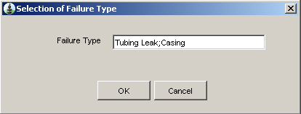

This filter clause can accept three types of values, numeric or text or date. The field type has to be specified within the filter clause as text_field or numeric_field or date_field.

date_field can only be used with filter_value=”{today}” variable (it can be ”+X{today}”, ”-X{today}”).

<CD_WELL>
<DM_DAILY filter_parameter="date_field=date_report" filter_value=”{today}” >
</CD_WELL >

The above configuration will generate DM_DAILY’s records where DM_DAILY.date_report is equal to current system date.

<CD_WELL>
<DM_DAILY filter_parameter="date_field=date_report" filter_value=”+1{today}” >
</CD_WELL >

The above configuration will generate DM_DAILY’s records where DM_DAILY.date_report is equal to current system date plus one means the next day.

Only the Date comparison will be performed with {today} or its overloaded variables (”+X{today}”, ”-X{today}”) , assuming the hours, minutes and seconds to zero.

Multiple Values
The filter also has the capability to take multiple values(separated by ";") e.g. in Failure by Failure Type report if the user enters "Tubing Leak;Casing", the report will show all records where Failure type is either 'Tubing Leak' or 'Casing'. This functionality is not supported for date_field option.

%= Operator
This filter also supports '%=' operator that will return all records where the string entered by user is part of the value e.g. if the user enters "Production" for assembly_name field of CD_PERFORATE, all records where assembly_name includes "Production" will be produced; e.g. Production Liner, Production Casing etc.

Pre-Defiend Values
The filter also has the capability to take the desired value directly from the config file instead of popping up a dialog box. For example if a developer wants to create a report that lists wells where Wellbore Zone status id 'Open - Producing' and 'Open - Not Producing'. They can use the following filter in the config file:

<CD_WELLBORE_ZONE filter_parameter="text_field=status_current" filter_value ="Open Producing;Open - Not Producing"/>

The above filter will produce all cd_wellbore_zone records where status_current is either Open Producing or Open – Not Producing

The user can also append filter_caption and filter_label at the end of this clause to change the default Caption and Label on the dialog box, e.g.:

<DM_PROD_EQUIP_FAIL filter_parameter = "text_field%=failure_type" filter_value ="Casing;Tubing" filter_caption="Selection of Failure Type" filter_label="Failure Type">

Picklists
The filter also has the capability to use picklists defined in OpenWells. This will allow the user to select the desired value from a drop-down list instead of typing it in the pop-up dialog box. For example if a developer wants to create a Failure By Failure Type report and wants the user to select the Failure Type from a list of failure types defined in a picklist, then picklist="YES" parameter has to be added in the config file:

<DM_PROD_EQUIP_FAIL filter_parameter = "text_field=failure_type" filter_caption="Selection of Failure Type" filter_label="Failure Type" picklist="YES"/>
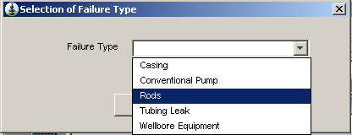

Using Parameter Value in OutputReports:

The selected date range is used to filter the records returned by OpenWells for an output report. The selected date range is also written in the xml data generated for the report under a custom table named parameter_item. This allows the report developer to use the parameter values in the report. The report developer only has to add the parameter_item table in the report. An example of what the generated xml will include for a parameter:

<parameter_item table=" DM_PROD_EQUIP_FAIL " column=" failure_type " start_param_value="Rods"/>
Multi-Select Picklists
If the developer wants to let the user select multiple failure types instead of only one, then this can be achieved by adding an additional parameter i.e. multiselect="YES".

<DM_PROD_EQUIP_FAIL filter_parameter = "text_field=failure_type" filter_caption="Selection of Failure Type" filter_label="Failure Type" picklist="YES" multiselect="YES"/>

The picklist can only be used for fields that have picklists defiend against them. For example the above example will only work if there is a picklist defined for DM_PROD_EQUIP_FAIL. failure_type.
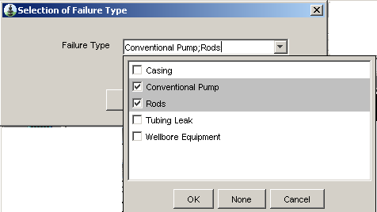

Custom Picklists
If the developer wants to use a custom picklist instead of the one defined in OpenWells for a certain field, then this can be achieved by adding the filter_value parameter (usage discussed earlier). An example

<DM_PROD_EQUIP_FAIL filter_parameter = "text_field=failure_type" filter_caption="Selection of Failure Type" filter_label="Failure Type" filter_value ="Casing;Tubing" picklist="YES" multiselect="YES"/>

Using the Tool Kit

General Notes
  - The EDM application for which the report is created must be used to test any new report added using EDM Administration Utility.
  - When changes are made to the Report Configuration (.XML) files and/or Crystal (.RPT) files, the files must be updated in the database using EDM Admin Utility and verified using your EDM application (i.e. OpenWells).

Adding a New Output Report
- Prepare all configuration and report files that will be used for the report generation.
- Use EDM Admin Utility to add the configuration and report files to EDM database.
  - Select the Custom folder, and follow the menu path New > Output Report folder to create a Report Type folder. The Report Types organize where the output report will appear in the application. For example, an output report that is to be available for the Site node in the OpenWells Well Explorer would be created within a node called "Site".

Output reports for OpenWells can be grouped under the following folders.
Folder Name | Associated Application Node in the OpenWells Well Explorer
Company | Output Reports found in the Company folder will be available for the Company node.
Project | Output Reports found in the Project folder will be available for the Project node.
Site | Output Reports found in the Site folder will be available for the Site node.
Well | Output Reports found in the Well folder will be available for the Well node.
Event | Output Reports found in the Event folder will be available for the Event node.
Wellbore | Output Reports found in the Wellbore folder will be available for the Wellbore node.
DDR | Output Reports found in the DDR folder will be available for the Daily Drilling Report and Daily Cost Report found in the OpenWells Report Preview Pane.

Output reports for Compass can be grouped under the following folders.

Folder Name | Associated Application Node in the Compass Well Explorer
Project | Project Summary reports
Site | Site Summary reports
Well | Well Summary reports
Wellbore | Summary of Wellbores reports
Design | Anti-collision reports
Survey | Survey reports
Planning | Planning reports

For the complete list of report aliases in MD_SYS_REPORT_TABLE table.
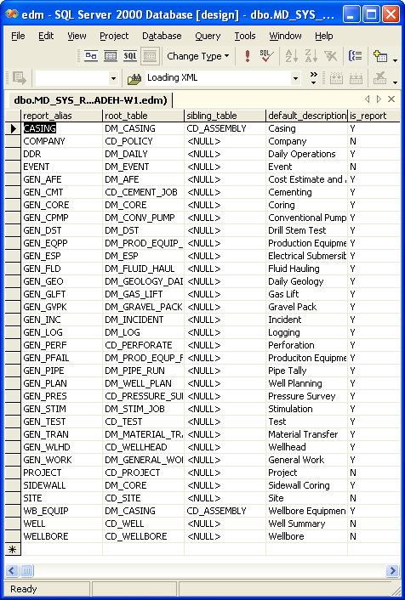 Figure 3.1

  - Select the Report Type created and follow the menu path New > Output Report.
  - The Create Output Report Wizard appears. Enter the name of the new Output Report and enter the path where the output report files are stored or click Browse to navigate to the location of the output report files.
  - Click Next.
  - All the files in the selected folder are included.
  - Click Finish.
  - The EDM Admin Utility displays a message informing you that the Output Report has been created without errors.
- Restart your EDM application (i.e. OpenWells) so that the new files will be loaded.
- Run the newly added report from your EDM application (i.e. OpenWells).

Creating a new Report Configuration file
The best way to create a new configuration file is to copy one of the provided samples and modify it to meet the new reports requirements.

- Find the configuration that is the most similar to the report to be created.
- Copy the sample configuration file to the new directory.
- Be sure to follow our report naming convention. For example, OpenWellsBHASummaryConfig.xml where OpenWells is the application name and BHA Summary Report is the report name. The keyword “Config” that follows the report name identifies this as a configuration file.
- Modify the configuration file to meet the new report requirements.

Updating a Report file
Updating a report means modifying the report file (XML or RPT files) using an external tool such as Crystal Reports development tools. After modifying a file, the file must be re-entered to the EDM database in order for Report Builder to access it.

- Modify the report file (XML or RPT file) using your tool of choice.
- Use the EDM Admin Utility to refresh the file in the database (see the EDM Admin Utility section).
- Restart your EDM application (i.e. OpenWells) and examine your changes.

Development Techniques for Crystal Reports

The aim of this section is to present the easiest way to create Crystal Reports.

- Run Crystal Development tool.
- Create a new blank Crystal Report.
- Using the Data Base Expert, add the XML data source.
  - Expand “Create New Connection”.
  - Expand ADO .NET (XML).
  - Define the XML file path to the schema file (For example, C:\Dev\CDDM\Common\Reports\OutputReports \Common\EDM.XSD).
  - Select the tables that are likely to be used and add them to the report. Note: Avoid adding all of the tables at the same time for performance reasons. Due to their large size, adding all of the EDM tables may cause run time problems.
  - The report is ready for editing now.
  - Providing more detail and the Crystal Reports interface is out of scope for this document.

Debugging Crystal Reports
One method of examining and testing a Crystal Report is to import it to the EDM database using the EDM Administration Utility and launch the report in your EDM application (i.e. OpenWells). However, for instant results, it will be faster to follow the steps below:

- Run ReportServiceTester.exe. The exact path to the file depends on the installation, however in a typical install, the file can be found at “C:\Landmark\EDT\EDM\Report Manager\ ReportServiceTester.exe”.

- The Report Service Tester will open as shown in Fig 4.1.
    - This is the interactive mode of Report Service, strictly used to facilitate development and troubleshooting the reports.
    - In order to be able to use the interactive mode, we should already have the XML data file, produced by any application such as OpenWells.
    - The report should be already existing in the application, run the report and use Report Manager to save the XML data.
    - Press Save button, and change the file type to XML. You can save the XML data in Report Manager.

- Enter two arguments; these arguments would specify the files that are needed for generating the report.
  - Config File path. It is a full path to the config file that defines this report. For instance, “OutputReports\Landmark\DDR\DailyCost\OpenWellsDailyCostConfig.xml” is a valid path
  - Data file is a full path to the data file which should be produced in the C:\Documents and Settings\USERNAME\Local Settings\Temp directory.

- There are three options available to Print / Export or Preview the report by clicking the appropriate button.

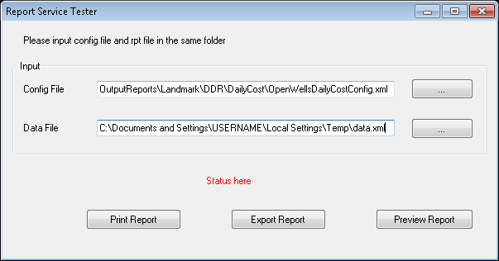
Figure 4.1

Developing Custom Reports
There are different methods of implementing custom reports. Depending on the complexity of the custom reports one of the implementation methods can be used.
- Custom reports using the generic XML data generation mechanism.
- Custom reports over ridding XML generation for a specified business objects in the in the configuration file.
- Custom reports completely over ridding the XML data generation system. This technique provides a full control over XML generation process.

Generic XML Data Generation
Generic XML data generation has been described in detail in the previous sections. This is the speediest method of developing a report. Using this technique developer’s time would be spent on actual designing of the report.

Over-riding XML Generation of a Specified Business Object
Using this technique the same generic process of producing XML will be used. However for a specified Business Object the XML generation would be over ridden by the report developers.
For example in the OpenWellsDailyCost Report provided by Landmark Graphics this method has been used.
The following XML code used at Daily Cost configuration file uses the over ridding the XML data generation for a specified business object. The generic XML data generation has been used, however for one of the EDM tables the XML data will be different than the generic report generation.
<data_source>
<data_generation>
<DM_REPORT_JOURNAL class="com.lgc.dws.common.reportbuilder.DailyCostXMLDataGenerator">
<DM_DAILY/>
<CD_WELL rel="parent">
<CD_SITE rel="parent">
<CD_PROJECT rel="parent">
<CD_POLICY rel="parent"/>
</CD_PROJECT>
</CD_SITE>
</CD_WELL>
<DM_EVENT rel="parent"/>
<CD_WELLBORE rel="parent"/>
<CD_RIG rel="parent"/>
</DM_REPORT_JOURNAL>
</data_generation>
</data_source>

In the above example XML tag <DM_REPORT_JOURNAL class="com.lgc.dws.common.reportbuilder. DailyCostXMLDataGenerator"> defines the Java class to produce XML data instead of the generic Report Builder.
This technique of over ridding one table is useful when only a small change in the XML data is needed.
This method does not change the metadata produced for the tables. It means the produced metadata would still remain the same as the metadata produced by the generic system.

Complete Over Riding of XML Generation
The third method of producing XML data is to completely take control of XML data generation. This is the most complex method of producing XML data and the report developer needs to implement a more complex logic to produce the XML data. For instance producing XML data for Daily Drilling Report has been implemented using this technique.

The following example from Daily Drilling Report illustrates the configuration section for producing the XML data.
<data_source> <data_generation_class>com.lgc.dws.common.reportbuilder.DailyDrillingXMLDataGenerator</data_generation_class>
</data_source>

Using this method requires to implement the XML generation in Java class. For instance above example defines a Java class to be used to produce the XML data for the report.

Developing Java classes for Custom Reports
The following process defines the steps required to implement a Java class for custom XML generation.
- Developing a Java class requires using a Java compiler. Any reputable Java compiler or IDE will be capable of compiling the Java code for custom reports. However we recommend using Eclipse IDE from www.eclipse.org. It is a free to use compiler-meeting all requirements needed for developing a Java custom class.
- Download Eclipse platform and install it on your computer.
- Run Eclipse platform and create a new Java project called “Custom Reports”.
- Create a new package using File/New/Package and enter “com.lgc.dws.common.reportbuilder” as the package name.

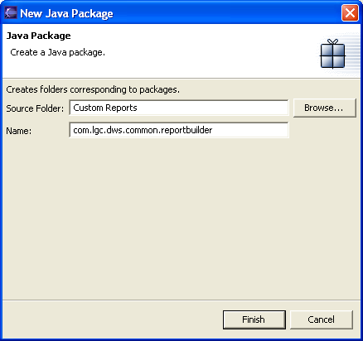

- At this stage Eclipse is using the default JRE. IT should be changed to the standard JRE used for OpenWells. At the time of writing this document Java j2sdk1.4.1_02 is used. Assuming the JDK has been installed on your system, the proper JDK should be used for compiling the custom report. Select Project/Properties/Add Library the following dialog would be displayed. Select “JRE System Library” and then press Next.
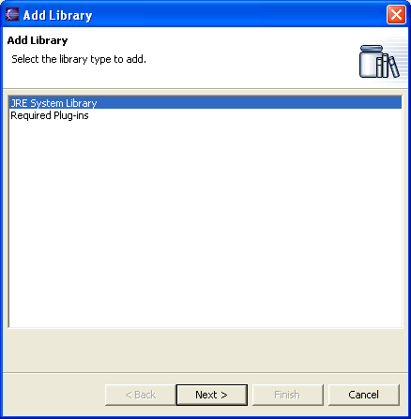

- At the “Add Library” dialog, there is a pull down menu to select the proper JRE. If the JRE you are intending to use is not available at the pull down it has to be added by pressing NEW button.
- Select the top level directory to the installed JRE path, and enter the proper JRE name similar to the illustrated picture and press OK.
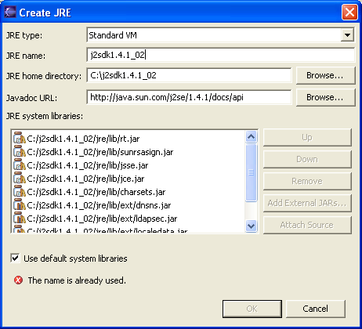

- Select Project/Properties; ensure only the proper JRE has been selected. If there are more than one JRE defined, remove the default JRE. The dialog should look as the following:
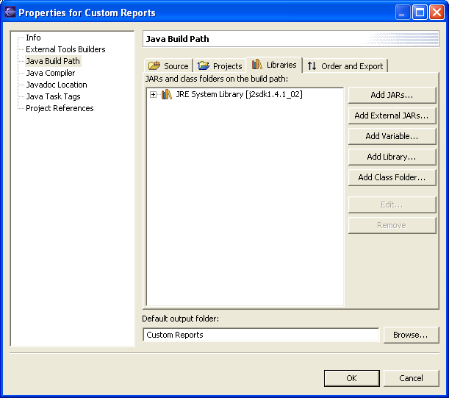

- Custom Report Java file will be an extension of the existing EDM source files. Consequently the proper Jar files for EDM should be also defined to the compiler. Select Project/Properties/Add External Jars… and select the following Jar files:
  - C:\Landmark\EDT\Common Files\Data Services\Common.Jar
  - C:\Landmark\EDT\Common Files\Data Services\JDataServices.jar
  - C:\Landmark\EDT\Common Files\Data Services\xerces.jar
  - C:\Landmark\EDT\Common Files\xalan.jar
Note 1: the path C:\Landmark\EDT\Common Files\ may vary according to your installation.

At this stage the properties dialog should look like:
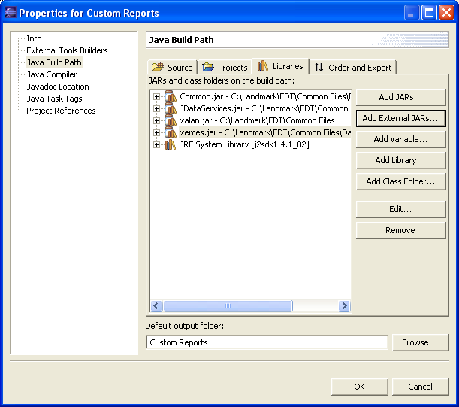

- At this stage all necessary settings are ready to create and compile the custom report. Select File/New/Class and fill new Java class as the following picture illustrates:
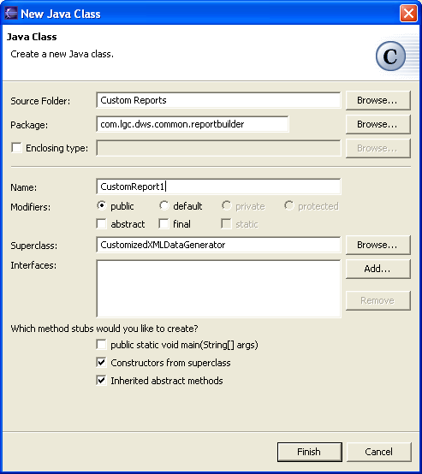

- Select Project/Rebuild All and compile the project. The main IDE should look like the following picture:
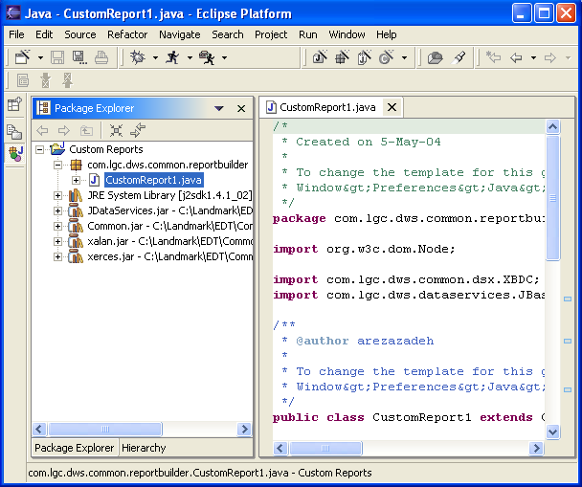

- At this stage the project should compile successfully. Next step is to update commonext.jar. The jar file commonext.jar is an extension Jar file designed to hold the custom report Java (or .class) files. In order to update commonext.jar, select File/Export… and choose “Jar File” option under the Export dialog. “JAR Export” dialog should be displayed and for the Jar file enter C:\Landmark\EDT\Common Files\ext\commonext.jar.
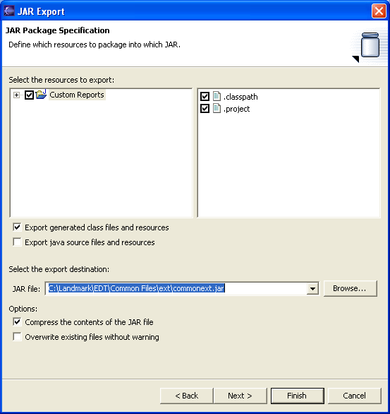

Note: the path may vary according to your installation. This is critical to have this path entered correctly. Otherwise at run time Report Builder will not be able to find the jar file and the correct custom report. This JAR file has been added to the batch files at C:\Landmark\EDT\OpenWells\Bin folder.
- The jar file containing the custom java classes to override the standard xml data generation completely or for a single node can be attached directly with the rpt and xml file using EDM Administration Utility instead of packing in commonext.jar and placing under C:\Landmark\EDT\Common Files\ext\ folder. Name the jar of your choice and mention under the settings tag of the report configuration file e.g.

<extension_jar>CustomReport.jar</extension_jar>

- Ensure the custom report files has been added, using Administration Utility as described in Components of a Report section
- The report should be ready to use now.

Including BHA and Wellbore Schematics in Crystal Reports

OpenWells output reports can show BHA and Wellbore schematics. The ability to include BHA schematics is available since 2003.14. The default BHA Summary Report, an event level report, shipped with OpenWells is an example of one such report. The ability to include Wellbore schematics is available in 2003.22 and later versions.

BHA Schematics

The following process defines the steps required to include BHA schematic(s) in an output report.

- Create a new Configuration XML file for the report and include all tables that are required for the report.

- Add the following line at the appropriate place in the hierarchy of tables in the configuration XML file

<DM_BHA_RUN schematic_plot="true"/>

For example the BHA Summary Report has this line under CD_WELL. In fact the best way to create a new configuration file for BHA schematics is to copy the BHA Summary Report configuration file and modify it to meet the new reports requirements.

The schematic_plot="true" tag in front of DM_BHA_RUN causes OpenWells to generate the BHA schematic for each DM_BHA_RUN record that will be generated.

- Create a new report in Crystal Reports and add all tables that are likely to be used In the report using the “Database Expert” option

- Add the following two tables to the report using the “Database Expert”:

  - DM_BHA_RUN
  - SCHEMATIC_PLOT

Note: The SCHEMATIC_PLOT table is not required in the Configuration XML file.

- Create a link between DM_BHA_RUN and SCHEMATIC_PLOT tables. Use the bha_run_id field for creating the link as shown in the following figure:

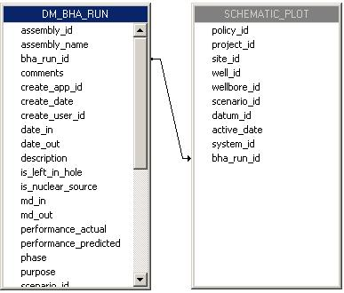

- Go to the field explorer and expand the SCHEMATIC_PLOT table to reveal all available fields of this table.

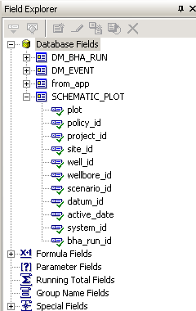

- Drag and drop the BLOB field SCHEMATIC_PLOT.plot field onto the report and place it at the appropriate place in the report depending upon the place where you want to see the schematic.

- Link all other tables used in the report.
- Add the report to OpenWells using EDM Admin Utility.
- Generate the report.
An example of such an output report is given in the figure.

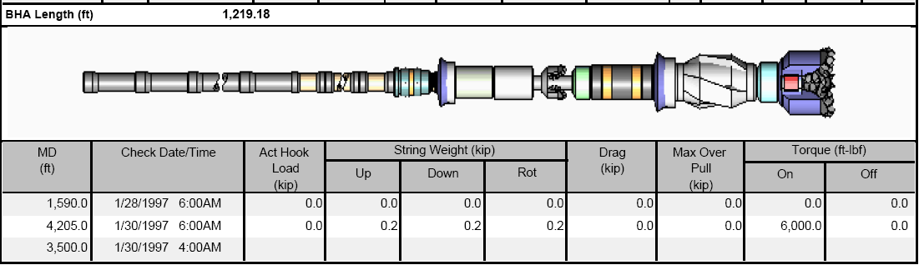

Miscellaneous Tips

- The default orientation of the schematic is horizontal. This orientation can be set by adding an additional argument orientation in the configuration file, e.g.:

<DM_BHA_RUN schematic_plot="true" orientation="vertical" />

Or
<DM_BHA_RUN schematic_plot="true" orientation="horizontal" />

- Uncheck the “Can Grow” property of the BLOB field SCHEMATIC_PLOT.plot. This can be done by right-clicking on the BLOB field and selecting “Format Graphic” from the drop down menu. The size of the image can be controlled by adjusting the size of the BLOB field in Crystal Reports.
- There could be more than one scenarios associated with the data. User can restrict to generate the schematic of the specific phase by including the tag phase with the desired pahse. E.g.

<DM_BHA_RUN schematic_plot="true" phase="ACTUAL" />

Wellbore Schematics

The following process defines the steps required to include Wellbore schematic(s) in an output report.

- Create a new Configuration XML file for the report and include all tables that are required for the report.

- Add the following line at the appropriate place in the hierarchy of tables in the configuration XML file

<CD_WELLBORE schematic_plot="true"/>

The schematic_plot="true" tag in front of CD_WELL causes OpenWells to generate the Wellbore schematic for each CD_WELLBORE record that will be generated.

- Create a new report in Crystal Reports and add all tables that are likely to be used In the report using the “Database Expert” option

- Add the following two tables to the report using the “Database Expert”:

  - CD_WELLBORE
  - SCHEMATIC_PLOT

Note: The SCHEMATIC_PLOT table is not required in the Configuration XML file.

- Create a link between DM_BHA_RUN and SCHEMATIC_PLOT tables. Use the wellbore_id field for creating the link as shown in the following figure:

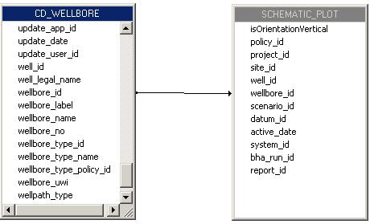

- Go to the field explorer and expand the SCHEMATIC_PLOT table to reveal all available fields of this table.

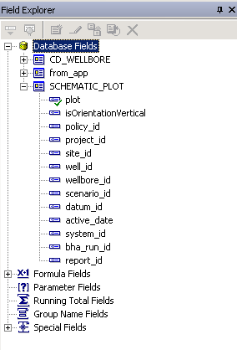

- Drag and drop the BLOB field SCHEMATIC_PLOT.plot field onto the report and place it at the appropriate place in the report depending upon the place where you want to see the schematic.

- Link all other tables used in the report.
- Add the report to OpenWells using EDM Admin Utility.
- Generate the report.
An example of such an output report is given in the figure.

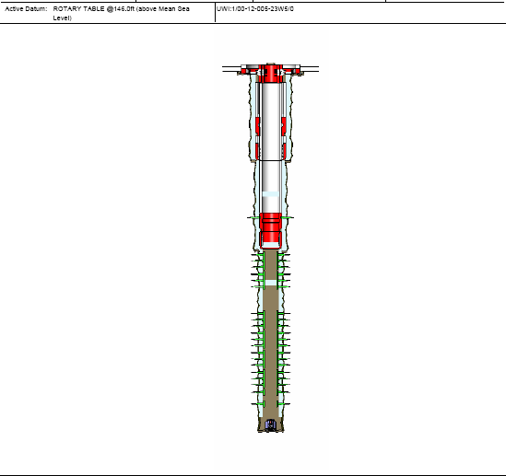

Miscellaneous Tips

- The default orientation of the schematic is horizontal. This orientation can be set by adding an additional argument orientation in the configuration file, e.g.:

<CD_WELLBORE schematic_plot="true" orientation="vertical" />

Or
<CD_WELLBORE schematic_plot="true" orientation="horizontal" />

- Uncheck the “Can Grow” property of the BLOB field SCHEMATIC_PLOT.plot. This can be done by right-clicking on the BLOB field and selecting “Format Graphic” from the drop down menu. The size of the image can be controlled by adjusting the size of the BLOB field in Crystal Reports.
- Like BHA schematic phase tag can be included here as well.
- User can also provide the following tags casing, cement, holesection, stimulation, perforation and wellhead with the wellbore schematic to generate these objects with the schematic all or individuals can be included. E.g.

<CD_WELLBORE schematic_plot="true" orientation="horizontal" />

<CD_WELLBORE schematic_plot="true" orientation="horizontal" phase=”ACTUAL" casing="TRUE"/>

<CD_WELLBORE schematic_plot="true" orientation="horizontal" phase=”ACTUAL" cement="TRUE"/>

<CD_WELLBORE schematic_plot="true" orientation="horizontal" phase=”ACTUAL" casing="TRUE" cementing="TRUE" holesection="TRUE"/>

Compass and Profile Plots integration.

The BHA and Wellbore schematic functionality is already available in the OpenWells output reports, now the Compass and Profile Plots can also be shown in the output reports.

Compass Plots

The following process defines the steps required to include Compass plots(s) in an output report.

- Create a new Configuration XML file for the report and include all tables that are required for the report.

- Add the following line at the appropriate place in the hierarchy of tables in the configuration XML file

<CD_WELLBORE compass_plot="true" compass_template="3d.wpc" quality="300"/>

The compass_plot="true" tag in front of CD_WELLBORE causes OpenWells to generate the graph mentioned in the template. If user does not mention any template then a dialog will appear asking for the Design and the template to select. This dialog picks the templates from the EDM Installation folder ...\Common Files\Templates\Compass

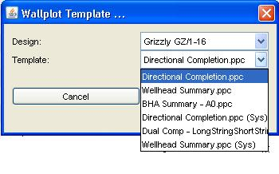

- Create a new report in Crystal Reports and add all tables that are likely to be used In the report using the “Database Expert” option

- Add the following table to the report using the “Database Expert”:

COMPASS_PLOT

Note: The COMPASS_PLOT table is not required in the Configuration XML file,
as shown in the following figure:

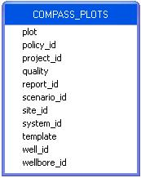

- Go to the field explorer and expand the COMPASS_PLOT table to reveal all available fields of this table.

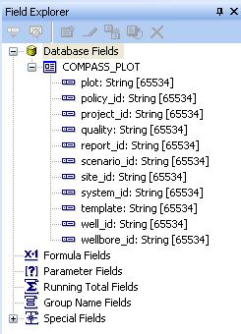

- Insert the Bitmap Image as OLE Object on the report. Right-click on the OLE Object and select “Format Graphic” from the drop down menu. Then go to Picture tab and click the Graphic Location function. Drag and Drop the COMPASS_PLOT.plot in the formula edit window.
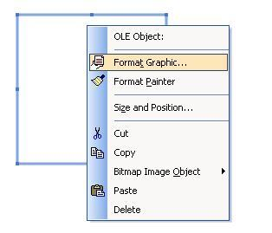
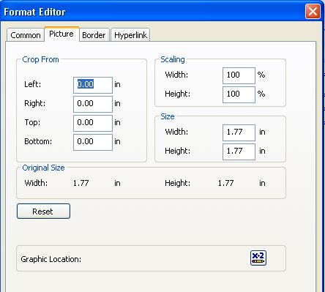

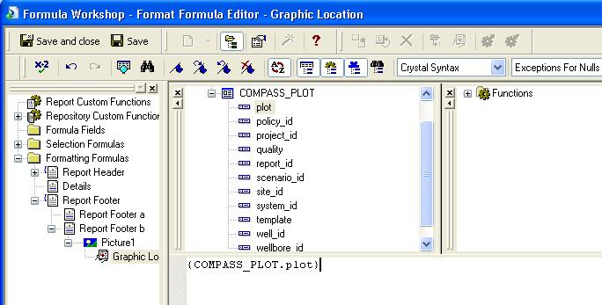

- Link all other tables used in the report.
- Add the report to OpenWells using EDM Admin Utility.
- Generate the report.
An example of such an output report is given in the figure.
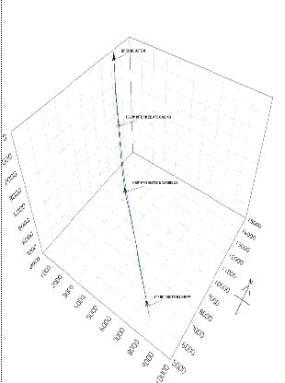
Miscellaneous Tips

- User can place the templates of his own choice in the installed folder of EDM ..\Common Files\Templates\Compass.
- Default quality of the plot is 300, the user can set it as 900 also.
- Uncheck the “Can Grow” property of the OLE Object. This can be done by right-clicking on the OLE Object and selecting “Format Graphic” from the drop down menu. The size of the image can be controlled by adjusting the size of the OLE Object in Crystal Reports.

Profile Plots

The following process defines the steps required to include Compass plots(s) in an output report.

- Create a new Configuration XML file for the report and include all tables that are required for the report.

- Add the following line at the appropriate place in the hierarchy of tables in the configuration XML file

<CD_WELLBORE wall_plot="true" wallplot_template="wellheadSummary.ppc" />

The wall_plot="true" tag in front of CD_WELLBORE causes OpenWells to generate the plot mentioned in the template. If user does not mention any template then a dialog will appear asking for the Design and the template to select. This dialog picks the templates from the EDM Installation folder ...\Common Files\Templates\WallPlots

- Create a new report in Crystal Reports and add all tables that are likely to be used In the report using the “Database Expert” option

- Add the following table to the report using the “Database Expert”:

WALL_PLOT

Note: The WALL_PLOT table is not required in the Configuration XML file.
as shown in the following figure:

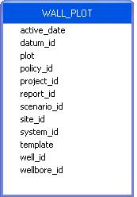

- Go to the field explorer and expand the COMPASS_PLOT table to reveal all available fields of this table.

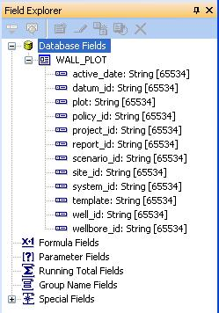

- Insert the Bitmap Image as OLE Object on the report. Right-click on the OLE Object and select “Format Graphic” from the drop down menu. Then go to Picture tab and click the Graphic Location function. Drag and Drop the COMPASS_PLOT.plot in the formula edit window.

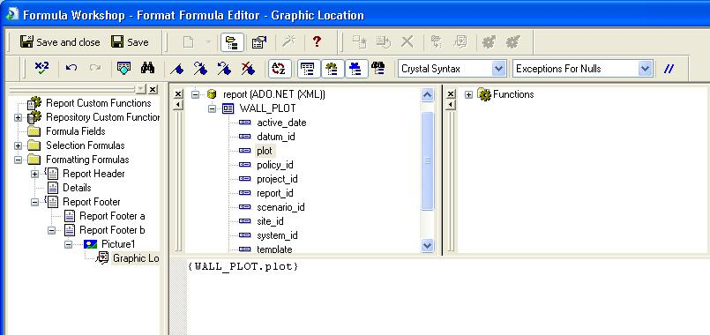

- Link all other tables used in the report.
- Add the report to OpenWells using EDM Admin Utility.
- Generate the report.
An example of such an output report is given in the figure.
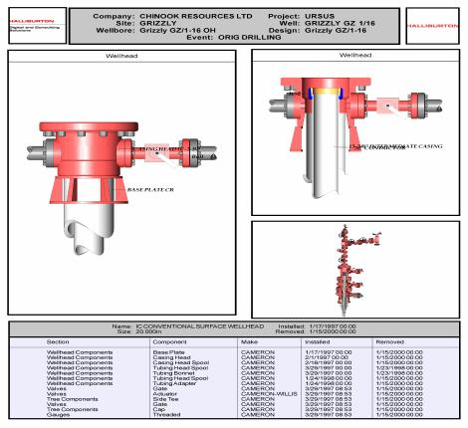
Miscellaneous Tips

- User can place the templates of his own choice in the installed folder of EDM ..\Common Files\Templates\Compass.
- Uncheck the “Can Grow” property of the OLE Object. This can be done by right-clicking on the OLE Object and selecting “Format Graphic” from the drop down menu. The size of the image can be controlled by adjusting the size of the OLE Object in Crystal Reports.
- Both Compass and Profile Plots can also be shown in a single report <CD_WELLBORE wall_plot="true" wallplot_template="wellheadSummary.ppc" compass_plot="true" compass_template="3d.wpc" quality="300"/>

